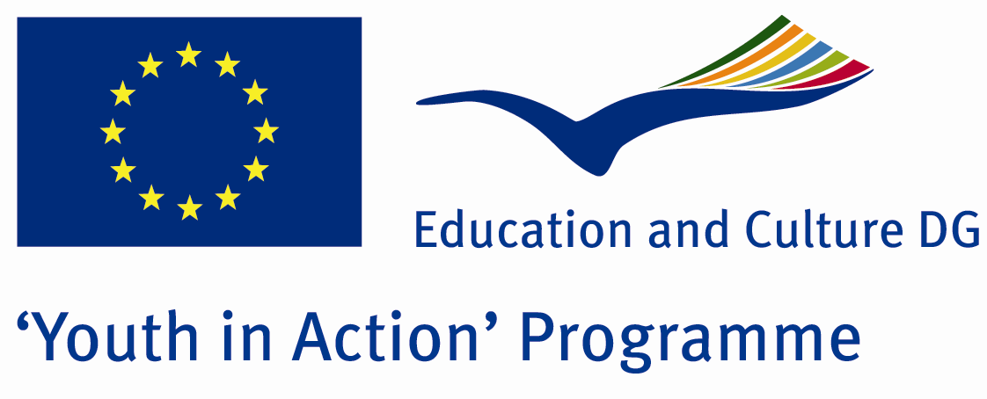

Whisper of hymns


ACTION 1.1 – Youth Exchange

20-27th November, 2011

Hatay, TURKEY

Please contact directly to;
adventurerpeacepigeons@gmail.com

Project Summary;

As is known, music is an activity which is used in all the areas of life like health , entertainment, art e.t.c….One of these areas is religion.In nearly all religions, definitely music is used.Music provides to better understood for all the activities…It gives motivation to participate any activity.Here in this Project, we try to learn the importance of the music on religions…What is the importance of music fort he religions? How can it provide the motivation? When is music used? When have relations been started between religion and music? We try to find answer for these questions in this Project..So, youngsters will understand better both religion and music…And so they will tolerate all the religions…Because in fact, everybody tries to be a good person which religion he believes…

Project Title; Whisper of hymns

Date and Venue ; 20-27th November, 2011, Hatay, Turkey .

Target Group ; Municipalities, City Councils and Non-Governmental organizations,
youth groups,culture and art groups,e.t.c

Participants ; 5 people from each country (over 18 -25 ). Totally 8 countries.

Conditions ; Accommodation, board and programme costs will be financed through European Commission Youth in Action Programme …Travel costs will be reimbursed in 70% (APEX Tarrifs). Organizations from all 27 EU member countries plus Liechtenstein , Norway and Iceland are eligible to take part.

Working language: English

Organizer; Adventurer Peace Pigeons

How to apply: If you are interested, please send your Part III forms to
by e-mail please. (Fulfilled Part III which you can find in the attachment, of course signed and stamped) ..

Next step 2;
Original send via regular post to this address please:

Ertan DERİN
Fevzi Çakmak Mahallesi Tuncer Sokak No:6 PENDİK/İSTANBUL/TÜRKİYE
e-mail : adventurerpeacepigeons@gmail.com
Mobile : 0090 542 393 93 90

If you have any questions you may contact with: adventurerpeacepigeons@gmail.com

Deadline for application; until 15 may 2011.

For Further information:
Contact Person
Ertan DERİN
Fevzi Çakmak Mahallesi Tuncer Sokak No:6 PENDİK/İSTANBUL/TÜRKİYE
e-mail : adventurerpeacepigeons@gmail.com
Mobile :0090 542 393 93 90

